Internal Gear Pumps | 

- Internal Gear Pump Overview
- How Internal Gear Pumps Work
- Advantages & Disadvantages
- Applications
- Materials Of Construction / Configuration Options
- Manufacturers

Internal Gear Pump Overview
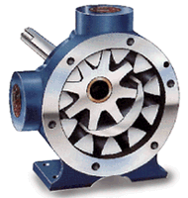
Internal gear pumps are well-suited for a wide range of viscosity applications because of their relatively low speeds. This is especially true where suction conditions call for a pump with minimal inlet pressure requirements.
For each revolution of an internal gear pump, the gears have a fairly long time to come out of mesh allowing the spaces between gear teeth to completely fill and not cavitate. Internal gear pumps successfully pump viscosities above 1,320,000 cSt / 6,000,000 SSU and very low-viscosity liquids, such as liquid propane and ammonia. In addition, lower speeds and low inlet pressures provide for constant and even discharge despite varying pressure conditions.
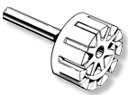
In addition to superior high-viscosity handling capabilities, internal gear pumps offer a smooth, nonpulsating flow. Internal gear pumps are self-priming and can run dry. Because internal gear pumps have only two moving parts, they are reliable, simple to operate, and easy to maintain. They can operate in either direction which allows for maximum utility with a variety of application requirements.

How Internal Gear Pumps Work
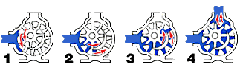
1. Liquid enters the suction port between the rotor (large exterior gear) and idler (small interior gear) teeth. The arrows indicate the direction of the pump and liquid.
2. Liquid travels through the pump between the teeth of the "gear-within-a-gear" principle. The crescent shape divides the liquid and acts as a seal between the suction and discharge ports.
3. The pump head is now nearly flooded, just prior to forcing the liquid out of the discharge port. Intermeshing gears of the idler and rotor form locked pockets for the liquid which assures volume control.
4. Rotor and idler teeth mesh completely to form a seal equidistant from the discharge and suction ports. This seal forces the liquid out of the discharge port.

Advantages  - Only two moving parts.  - Only one stuffing box.  - Positive suction, nonpulsating discharge.  - Ideal for high-viscosity liquids.  - Constant and even discharge regardless of pressure conditions.  - Operates well in either direction.  - Can be made to operate with one direction of flow with either rotation.  - Low NPSH required.  - Single adjustable end clearance.  - Easy to maintain.  - Flexible design offers application customization. | Disadvantages  - Usually requires moderate speeds.  - Medium pressure limitations.  - One bearing runs in the product pumped.  - Overhung load on shaft bearing.

Applications
- Barge, tanker, and terminal loading and unloading.
- Filtering.
- Circulating.
- Transferring.
- Lubricating.
- Booster.
- General industrial.
- Marine applications.
- Petrochemical.
- Light, medium, or heavy-duty service.

Materials Of Construction / Configuration Options
- Externals (head, casing, bracket) - Cast iron, ductile iron, steel, stainless steel, Alloy 20, and higher alloys.
- Internals (rotor, idler) - Cast iron, ductile iron, steel, stainless steel, Alloy 20, and higher alloys.
- Bushing - Carbon graphite, bronze, silicon carbide, tungsten carbide, ceramic, colomony, and other specials materials as needed.
- Shaft Seal - Lip seals, component mechanical seals, industry-standard cartridge mechanical seals, gas barrier seals, magnetically-driven pumps.
- Packing - Impregnated packing, if seal not required.

Manufacturers
- Viking Pump Inc.
- Viking Pump (Europe) Ltd.
How A Gear Pump Works

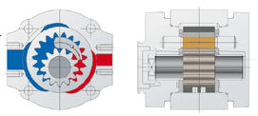

Bibliography

http://en.wikipedia.org/wiki/Gear_pump

http://www.pumpschool.com/principles/internal.htm

http://www.eckerle.com/english/ubersicht-eips3.html

