Rotary Sliding Vein Pump

- 3 Types of pumps
  - Centrifugal
  - Rotary
  - Reciprocating

Rotary Pumps

- Versatile
- Make up 10% of the pumps used in industry today
- Positive Displacement
- Types Include
  - 3, 2, and 1 screw
  - external and internal gear
  - lobe
  - flexible and sliding vein
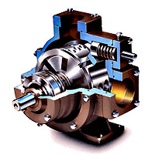

Sliding Vein Pump

- Operate at low speeds (1000rpm)
- Best for low-viscosity fluids
- Advantages
  - Self priming
  - Can run dry for short periods of time
  - Easy maintenance
  - Develops a good vacuum
- Disadvantages
  - Not well suited for high pressure or viscosity fluids
  - Not well suited for abrasive fluids

References:

http://www.pumpschool.com/principles/vane.htm
http://www.mcnallyinstitute.com/12-html/12-03.html
http://jan.ucc.nau.edu/~wittke/Microprobe/Vacuum-MechPump.html

