4 Lobe in 5 Lobe
Rotor Oil Pump
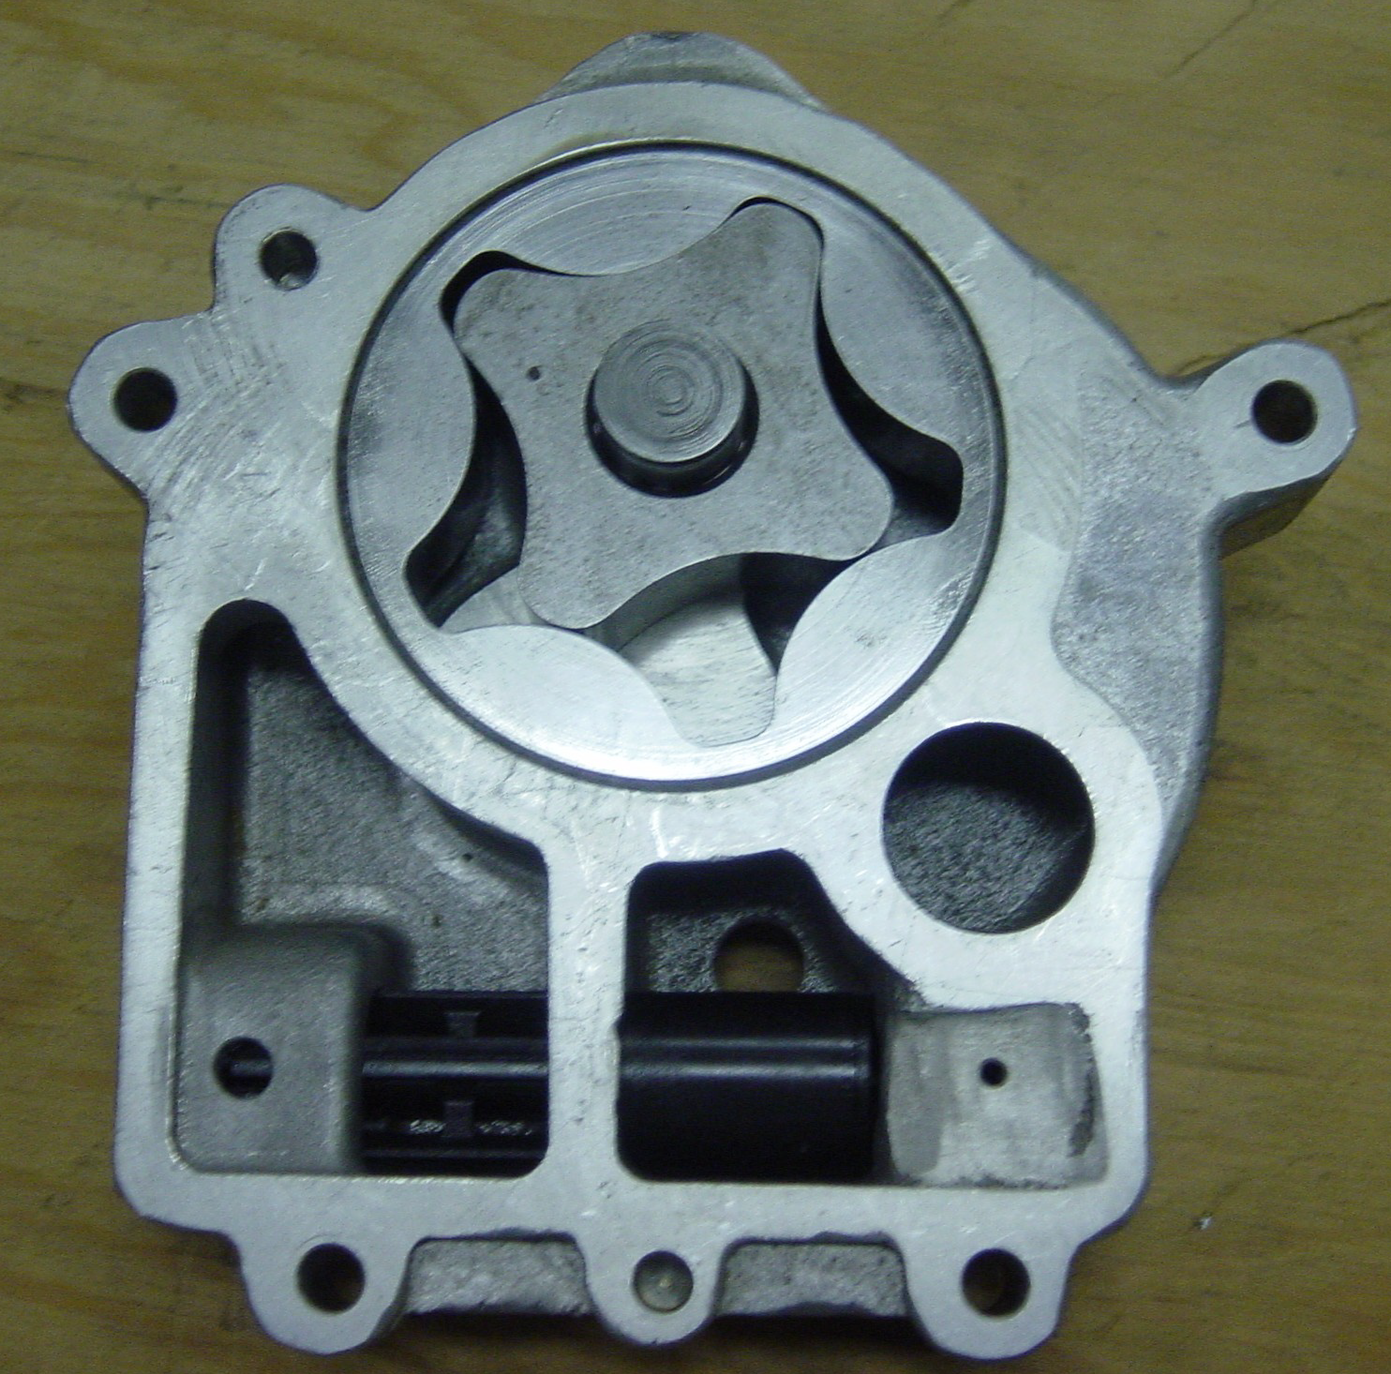

Presented by: Rob Sterling
How does it work?
- 61 tooth gear and shaft
- Internal (drive) 4 lobe gear
- External (driven) 5 lobe gear
- Inlet port
- Outlet port
- Pressure relief valve
Applications
- Engine / Transmission Lubrication
- Hydraulic Oil Pump
- Fuel Pump
- Hydraulic Motor
- Hydraulic Steering

