What is an Internal Gear Pump?

- An internal gear pump is used for the displacement of liquids, or transfer from one place to another.
- Often pressurized

What is it used for?

- Boiler
- Burner
- Lubricating parts
- Locomotive and barge engines
Types

Internal Gear | External Gear | Vane
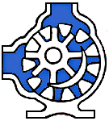 | 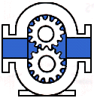 | 
Flexible Member | Lobe | Circumferential Piston
 |  | 

Bibliography

http://www.pumpschool.com/intro/pdtree.htm

http://www.ipfonline.com/storefront/fluidtech/fuel_injection.htm

http://www.pumpschool.com/principles/internal.htm#advantages

