Oil Pump Dissection:
Internal Gear Pump
AKA
“Outside Gear/Inside Gear”

Jordan Lee
ME100

How does an internal gear pump work?

- Anatomy

- Stages of Function

- Advantages and Disadvantages

- Conclusion

- Questions
Anatomy

- Four key components
  - Pump housing
  - Idler – interior spur gear
  - Rotor – exterior spur gear
  - Crescent
Stages of Function

- Oil enters the gap between the idler and rotor

- Oil travels with rotation of the idler and rotor, dividing at the crescent
  - Seal is created between the suction and discharge ports through division

- Gear gaps are constant, providing constant flow volume control

- As teeth completely mesh and seal, oil is forced out the discharge port

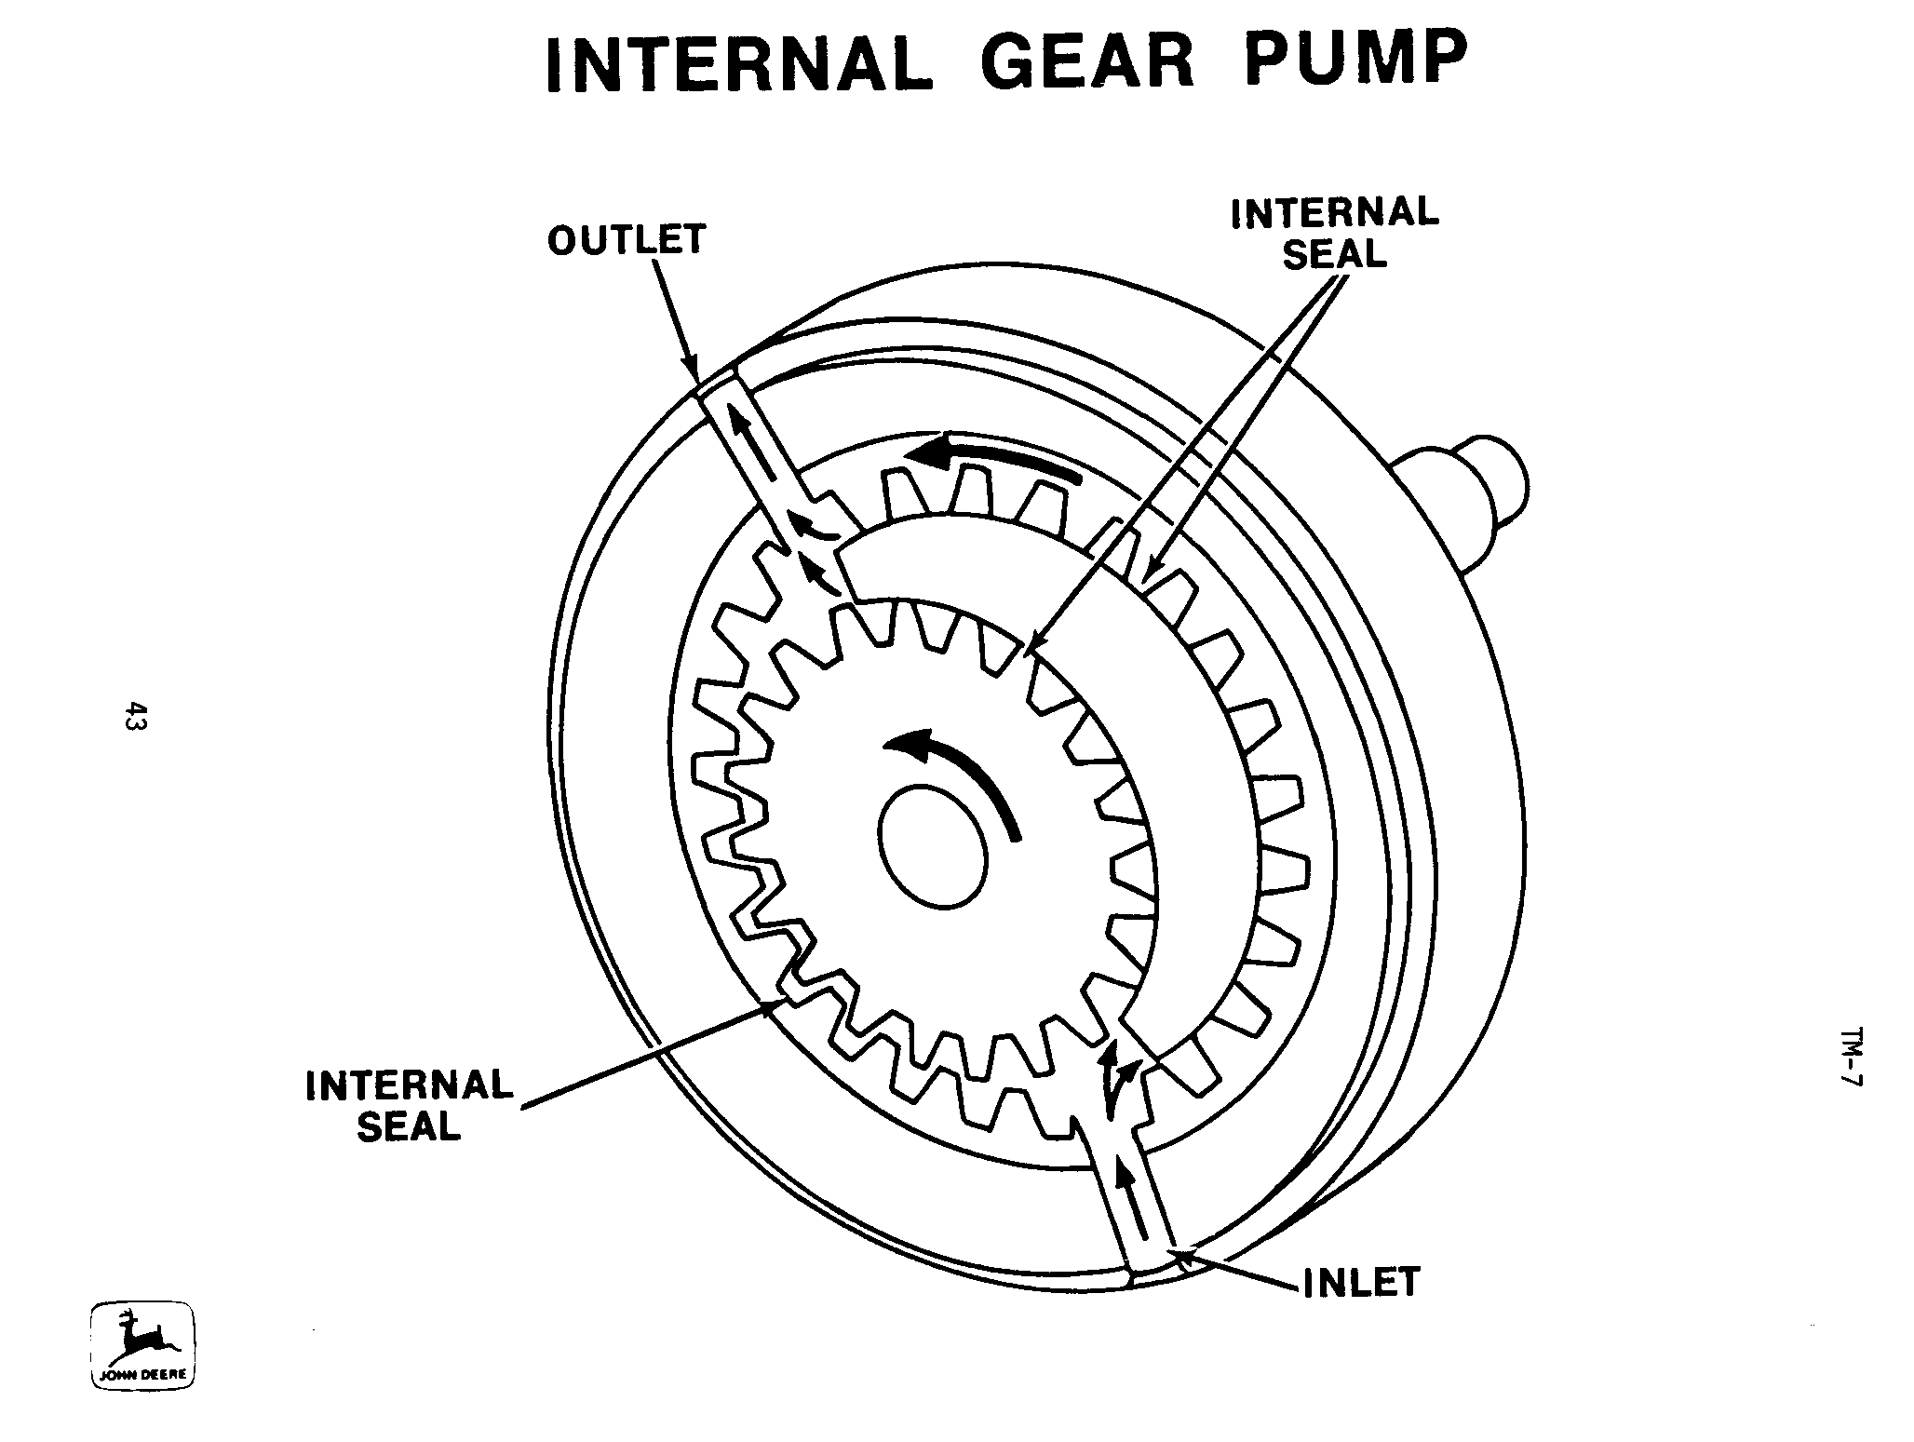
Picture taken from:
http://cast.csufresno.edu/agedweb/agmech/graphics/hydraulics7.gif
Advantages and Disadvantages

Advantages | Disadvantages
- Simplistic design | - Requires moderate speeds
- Positive suction | - Medium pressure limitations
- Ideal use for high viscosity substances | - One of the bearings must run within the substance pumped

Conclusion

Through this presentation, one should:
- Recognize the components of;
- Understand the functions of;
- Be familiar with the advantages and disadvantages of;
An internal gear pump.

Questions

Resources

All information and more can be found at:
Internal Gear Pumps:
http://www.pumpschool.com/principles/internal.htm

