Advantages and Disadvantages of Lobe Pumps

By: Rob Rolufs

4 in 5 Lobe Pumps

Presentation objective: To familiarize the class with the advantages and disadvantages of lobe pumps.

Advantages

-Minimal metal to metal contact between the rotors (prevents wear and tear)
-Pump only in one direction (no backflow)
-Durable (made of stainless steel)
-Can handle high viscosity fluids efficiently



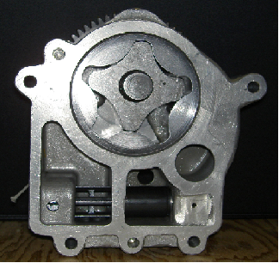

Disadvantages

-Most lobe pumps require timing gears
-Since the rotors don’t touch each other in most lobe pumps, low viscosity fluids have a harder time passing through the lobes
-May require factory service to repair
Tri Lobe Pump



Conclusion

After examining the advantages and disadvantages of lobe pumps, we can conclude that lobe pumps are optimal for highly viscous fluids such as motor oil.

References: www.pumpschool.com

