Sliding Vane Pump

Manufacturing Components:

- Externals (head, casing, bracket) - Cast iron, ductile iron, steel, and stainless steel.
- Vane, Pushrods - Viton®, Ryton®, PPS, carbon, Teflon®
- Liner & End Plates - Cast iron, ductile iron, steel, carbon, and stainless steel.
- Bearing Cap - Cast iron, ductile iron, steel, and stainless steel.
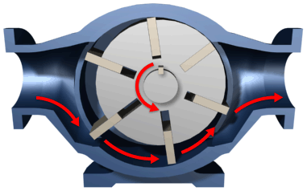
- Shaft Seal - Component mechanical seals, industry-standard cartridge mechanical seals.

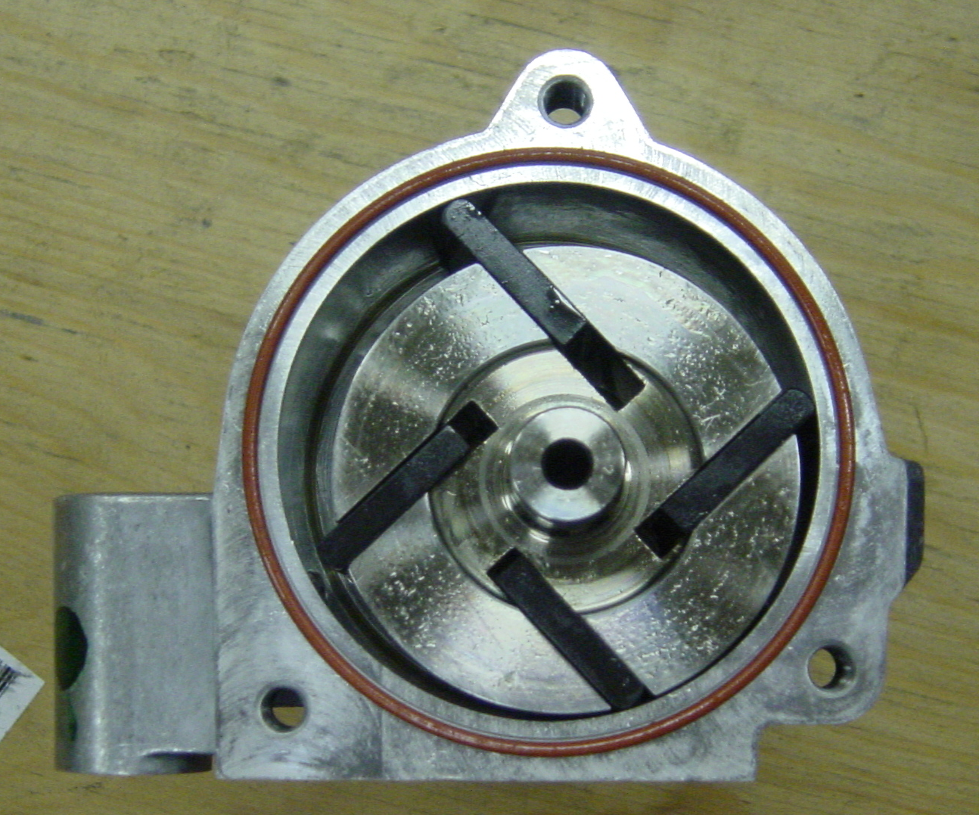

Sliding Vane Pump Advantages
- Medium capacity
- Medium speed
- Thin liquids
- Handles various liquids (not just oils)
- Can run dry for short periods
- Can have one seal or stuffing box
- Develops good vacuum (can even run for while with small air penetration)

Sliding Vane Pump Disadvantages
- Can have two stuffing boxes
- Complex housing
- Not suitable for high pressures
- Not suitable for high viscosity
- Not good with abrasives

Applications:

Various Versions of Sliding Vane Pumps are found in such devices:
- Aviation Service - Fuel Transfer, Deicing
- Auto Industry - Fuels, Lubes, Refrigeration Coolants
- Barge Unloading
- Bulk Transfer of LPG and NH₃
- LPG Cylinder Filling
- Ethanol/Alcohol Refining

