Passive Solar
Hot Water Heating

By Jonathan Cheung

Components:

Passive solar hot water systems are made up of:
- solar collectors
- piping
- storage tanks
- circulatory controls

Solar Collectors
- flat-plated
- insulated box made of metal or plastic
- contains a dark absorber plate beneath a translucent cover

Tanks
- well-insulated
- may use converted electric/gas water heater tanks for storage

Controls, Circulator
- Differential temperature controller monitors temperatures at solar collector outlet and at storage tank.
- When the collectors are warmer than the tank, cold water from the storage tank is directed to the collector where it is heated. Once heated, the water is returned to the storage tank.

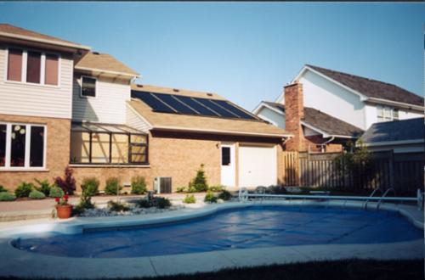
Types of Passive Systems:

- Batch heaters:
- consists of one or more metal water tanks painted with a heat absorbing black coating
- placed in an insulating box with a glass or plastic cover that admits sunlight to strike the tank directly
- batch system's storage tank is the collector as well
- systems will use the existing house pressure to move water through the system.
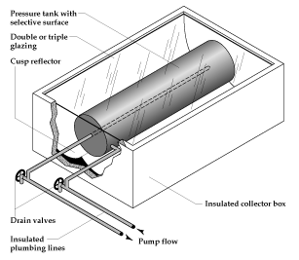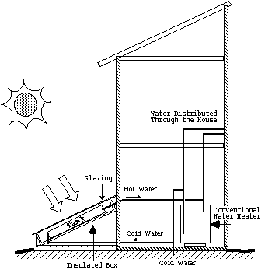

- Thermosiphon systems
- rely on the natural process of that causes warm water to rise.
- system circulates water through solar heat collectors and then into a holding tank, which is located above the collector.
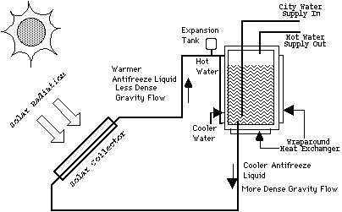
Initial Cost:
A passive system will cost about $1,000 to $2,000 installed and will provide up to 80 gallons of hot water per day.

Installation:
- An experienced contractor should install solar water heating systems.
- Roof penetration, additional piping and insulation is usually required

Operation:
- Properly designed solar water heaters are completely automatic and are left in operation year-round. Active systems have a small electronic control with one or more indicator lights to let you know if there is a malfunction.

Advantages:
- nonpolluting
- saves energy
  - solar water heating systems can reduce the use of electricity to heat water by as much as 80%
- conserves non-renewable energy sources like oil, coal and natural gas for other uses
- solar water heaters saves money
  - an average household with an electric water heater spends about 25% of its home energy costs on heating water. The average solar water heating system pays for itself over the long run

Disadvantages
- an unshaded, south-facing location is necessary
- systems are suitable only for warm climates where there is no risk of freezing
- simple batch heater systems that use storage tanks housed in insulated boxes to heat water need a roof or other structure strong enough to support them.
- up-front purchase and installation costs, usually between $1000 and $3000, are higher than those of conventional electric or gas water heaters

References:
http://www.toolbase.org/techinv/techDetails.aspx?technologyID=112
http://www.greenbuilder.com/sourcebook/HeatCool.html
http://www.eere.energy.gov/de/solar_hotwater.html

