
MICKEY HO
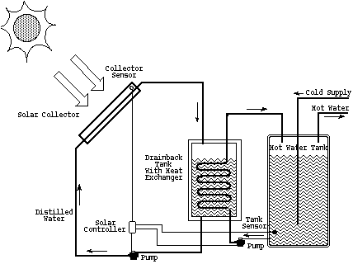

FUNDAMENTAL REQUIREMENT FOR A SOLAR SYSTEM
- A SUNNY LOCATION
- HAVE FULL SUN FROM 9AM TO 3PM
- FACE SOUTH AT SAME ANGLE AS LATITUDE (30° ± 15°)

FIVE MAJOR COMPONENTS IN ACTIVE SOLAR WATER HEATING SYSTEMS:
- COLLECTOR(S) – to capture solar energy
- CIRCULATION SYSTEM – to move a fluid between the collectors to a storage tank
- STORAGE TANK
- BACKUP HEATING SYSTEM
- CONTROL SYSTEM – to regulate the overall system operation

DIRECT SYSTEMS (OPEN LOOP SYSTEMS):
- WATER DIRECTLY CIRCULATES INTO COLLECTORS FROM STORAGE TANK

DRAINDOWN | RECIRCULATING
- VALVE PURGES WATER INTO COLLECTORES – when outdoor temperature ≥38°C  - Allows system collectors to refill and heating operation to resume | - PUMPS HEATED WATER FROM STORAGE TANK THROUGH COLLECTORS WHEN TEMPERATURE ≤38°C

DRAWBACKS:
DRAINDOWN VALVES FAILING – causing expensive breakage of solar collectors

PERIODIC DRAINGING – causing buildup of mineral deposits in collectors (inefficient)

CIRLUATING BUILDUP DURING FREEZE CONDITIONS – effectively cools the water (wasting energy)

INDIRECT SYSTEMS (CLOSED LOOP SYSTEMS):
- USES DISTILLED WATER AS COLLECTOR CIRCULATING FIULD
- ONLY HAVE WATER IN SYSTEM WHEN PUMP IS FUCTIONING
- VERY RELIABLE AND WIDELY USED

Functions:
Fluids circulated into collectors separated from heated water for home use by double walled heat exchanger
Heat exchanger used to transfer heat from fluids (water, oil, antifreeze, or refrigerant) to water used in home
Summary:
- Prove 50-80% of home’s hot water needs
- 10-15 square feet of solar collector area per person
- Storage tank: 20-30 gallons per person
- Pipes: well insulated and close to avoid deficiency
- Select systems tested and certified by the Solar Rating and Certification Corporation (SRCC)

Reference:

http://www.greenbuilder.com/sourcebook/HeatCool.html#ACTIVEDHW

http://www.newenergy.org/sesci/publications/pamphlets/active.html

http://www.solar-rating.org/

http://www.energystar.gov/ia/new_homes/features/ESSolarWaterHeating.pdf

