Bearings:
Keeping Everything Running

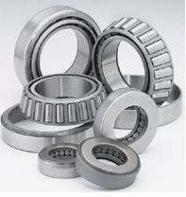

Brandon Moy
20217513

4M-B

What are Bearings?

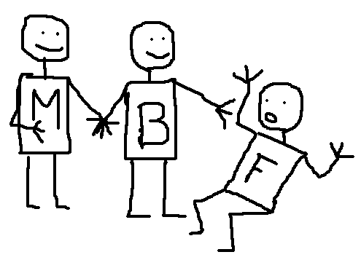
Fight Friction!

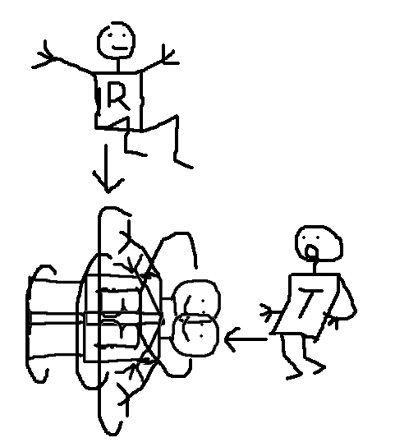Rotary Bearings

Rotational Motion

Thrust
Radial

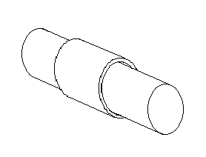Plain Bearings

Cylinder + Rod + Lube

Pro
Simple
Light, Compact, Easy to replace, Cheap

Con
Wear quickly

Rolling Element Bearings

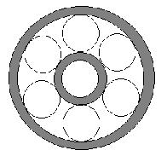
Rolling Element + 2 Cylinders

Roll not slide

Ball Roller Thrust
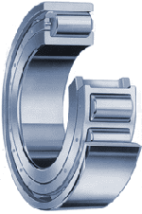
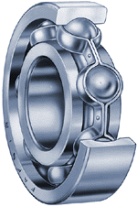
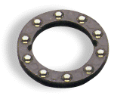



Source: http://www.timken.com/products/bearings/products/

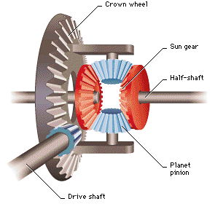Differential
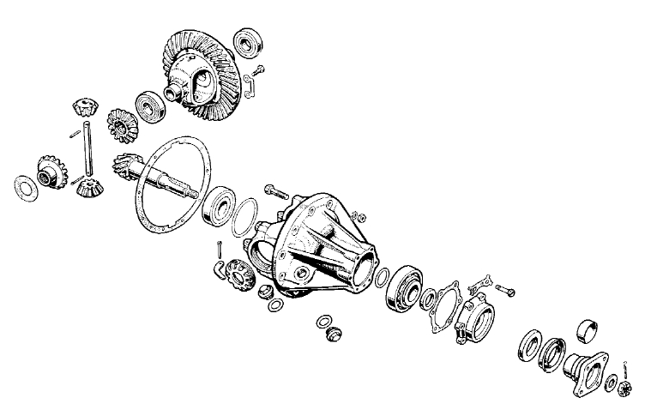

Source: http://catalog.roversnorth.com/catalog/LR04/LR04_pages34_37/image/Ser%20II%20diff356.jpg

Sources

Oberg & Jones. “Machinery’s Hand Book”. 1981. 21st Edition

http://science.howstuffworks.com/bearing.htm

http://en.wikipedia.org/wiki/Bearing_(mechanical)
http://nskaustralia.com.au/page/6view.html

