Bearings
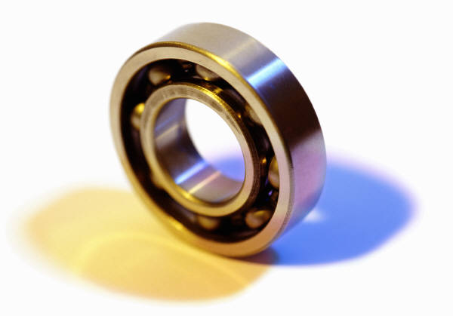
By Srdjan Popovic

What are Bearings?

- Small, circular discs that can be found in many of today’s modern machines
- Purpose: They make the machines possible
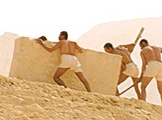
- Egyptians would put logs under heavy stones and roll them to their building site – a type of bearing

How Bearings Work?

- Friction between two objects wears objects out
- Bearings greatly reduce friction; provide smooth metal balls/rollers and smooth inner/outer surface for balls to roll against
- Balls or bearings bear load, allowing smooth spin
- Two basic load types: radial and thrust
- Radial: along bearing’s axis of rotation
- Thrust: perpendicular to bearing’s axis of rotation
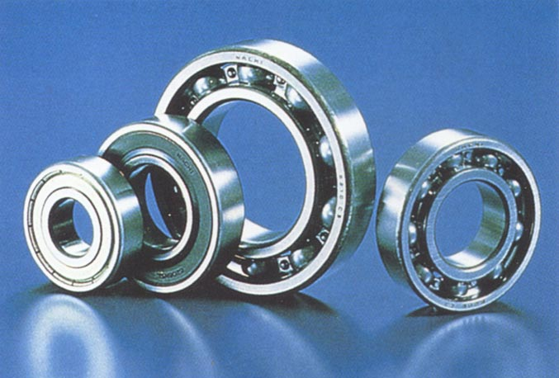
- Bearings can encounter one of or both load types
- Evaluated based on how much load it can carry, speed at which it can carry load, wear-out time period.
Types of Bearings

- Rolling-Element bearings and Plain bearings
- Plain Bearings: based on sliding action
- Roller-Element bearings: based on rolling action

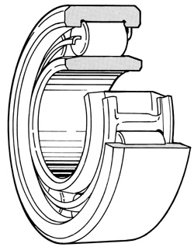
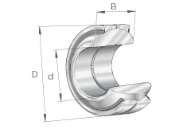

Plain bearing Roller-Element bearing

- Different kinds of roller-element bearings
- Ball Bearings: one point of contact (sphere); light loads
- Roller Bearings: one line of contact (cylinder); heavy loads
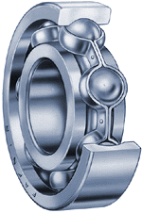
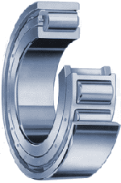

Ball bearing Roller bearing
Interesting Uses

- Magnetic bearings used for high-speed devices – allow for machines to run at high rpm.
- Earthquake-proof buildings – columns of airport rest on large steel ball bearings.


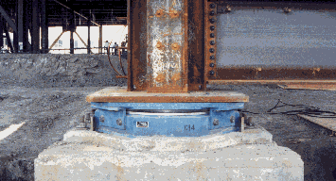

References

http://science.howstuffworks.com/bearing3.htm
http://www.bearings.machinedesign.com/guiEdits/Content/BDE_6_4/bdemech6_40.aspx
http://www.earthquakeprotection.com/sfo_airport.htm
http://www.bbc.co.uk/history/ancient/egyptians/great_pyramid_01.shtml
http://www.jocmachinery.com/html_en/bearing.htm
http://medias.ina.de/medias/it!hp.ec.br/GE..FO-2RS

