Introduction to Boilers

By: Howie Lau

ID: 20207634

Objective

To deliver a brief introduction to boilers, what they do and the different types of boilers available on the market.

What are boilers?

A boiler is a device in which water is heated and circulated as steam or hot water for the purposes of heating or for power. Typically in a building, a boiler is used to heat water and space and is usually associated with a radiant heat hydronic system.

What is the difference between a boiler and a furnace?

Boiler

-a device that creates hot water

-typically used in a hot water based heating system (uses hot water to deliver heat)

-usually pressurized system

Furnace

-a device that creates hot air

-used in a hot air based heating system (uses a blower and ductwork to deliver heat)

-unpressurized system

The Three Main Types of Boilers

-Fire Tube Boiler

-Water Tube Boiler

-Electric Boiler

Fire Tube Boiler

-heats water through the use of a series of tubes submerged in a tank of water, hot gases run through these tubs and heat is transferred to the water as it passes

-boilers of this type are typically in the range of 20 to 800 boiler horsepower (196.19 kW to 78747.6 kW) and run at pressures up to 150 psi

-usually for low pressure applications

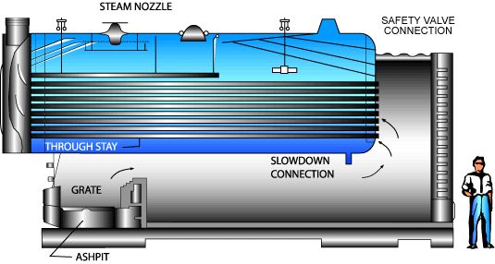

Water Tube Boiler

-heats water through the use of a series of tubes filled with water, the water is heated by fire or hot gases flowing over the tubes

-most high pressure boilers are of this type as the water filled tubes in a water tube boiler can with stand more pressure than the gas filled tubes of a fire tube boiler

-sizes range from residential types up to large utility boilers, pressures in these boilers range from 15psi to 3500psi

-more expensive than a fire tube boiler because of thicker walls required due to the high pressures that it must withstand
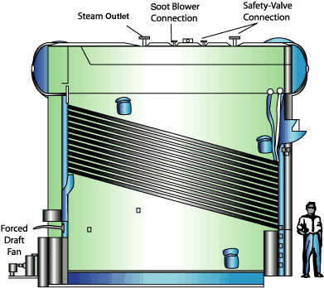

Electric Boiler

-heats water through the use of electricity

-ratings from 5 to 50000kW

-can fulfill any HVAC requirement from humidification to being a primary heat source

-most residential electric boilers range from 1-50kW

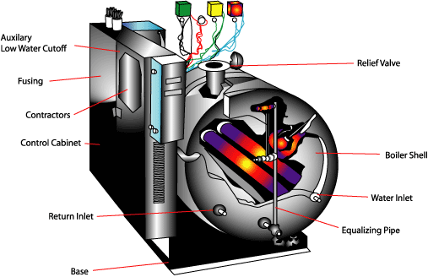

Energy Star Qualified Boilers

-Old boilers had an efficiency of 55-65%

-most new boilers are about 80% efficient

Energy Star boilers are at least 85% efficient, usually are condensing boilers, and have features such as

-electric ignition, no pilot light used

-new combustion technologies (better control systems and better burn to extract more heat out of fuel)

-sealed combustion (using outside air instead of drawing air from inside the house)



Overall View of Boilers

-Boilers can be used for either heating space, or water or both at the same time

-there are many various types of boilers and many applications for a boiler (from heating water to pushing a generators turbine)

-a boiler can be turned into a furnace by blowing air over the water tubes and circulating that air to deliver the heat

-a radiant boiler system is typically more expensive similarly sized forced air furnace system(may depend on the install location)

Eg. A forced air furnace system for a 2000 sq.ft. home will cost about $3000-$4500, while a hydronic boiler system will cost about $4000-$5000

-a boiler will typically last 30-45 years, a furnace will last only 10-25 years

-a hydronic boiler system will not affect air quality inside the home and costs much less to maintain compared to a forced air furnace system which involves many moving parts and needs maintenance parts such as filters, bearings, belts, fans and motors.

-a hydronic boiler system can increase the value of a home

Problems with using a boiler

If a boiler isn’t maintained and repaired carefully, a boiler can be extremely dangerous

Problems that can occur on a boiler:

-leaks
-malfunctioning safety relief valve
-improper water cut off
-malfunctioning control devices
-buckling
-excessive pressures

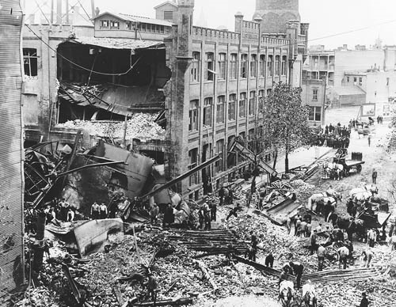
Fig. 1-1909 Milwaukee boiler explosion

Conclusion

Using a boiler system is an efficient method of heating a building, since it can be used to heat both water and space. Although it costs more than a forced air furnace upfront, it is cheaper to run and maintain in the long run.

Resources

Radiant Heating Equipment
http://www.radiantheat.net/faq_equipment/

An Industrial Boilers Information Page
http://www.iqsdirectory.com/info/industrial-boilers/

Boilers: Energy Star
http://www.energystar.gov/index.cfm?c=boilers.pr_boilers

Boiler Terms and Explanations
http://www.alternateheatingsystems.com/boiler_terminology.htm
Boilers and Boiler Safety
http://www.license.state.tx.us/boilers/blr.htm#what

Femp Operations: Types of Boilers
http://www.eere.energy.gov/femp/operations_maintenance/technologies/boilers/types.cfm

