Powertrain

By: Alex Forsea

Definitions
Powertrain: A group of components used to transmit engine power to the driving wheels. It is made of the engine, clutch, transmission, drive shaft, differential, and axle shafts.
Clutch: Engages or disengages the engine and transmission.
Transmission: Gear that transmit power from the engine to the drive shafts.
Differential: A device made of gears. Changes the direction of a rotating shaft and allows for the wheels to spin at different rates.
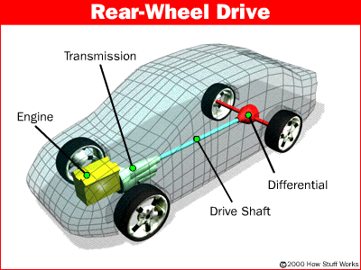

Purpose of the Differential
- To aim the engine power at the wheels
- To transmit the power to the wheels while allowing them to rotate at different speeds

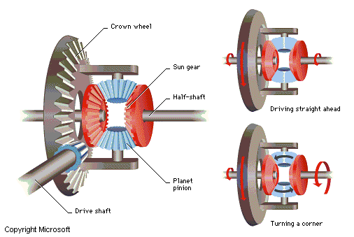

References:

http://auto.howstuffworks.com/differential
Microsoft Encarta 98 Encyclopedia

