Bearings

By Ronsen Abbas

- Definition of a Bearing
- Sliding Bearing vs Rolling Contact
- Types
  - Ball Bearings
  - Roller Bearings
    - Needle Bearings
  - Ball Thrust Bearings
  - Roller Thrust Bearings
  - Tapered Roller Bearings
- Interesting Uses
  - Magnetic Bearings
  - Giant Roller Bearings

Definition
“A machine or structural part that supports another part.
A device that supports, guides, and reduces the friction of motion between fixed and moving machine parts”dictionary.com
- A part that reduces friction between two contact surfaces
- Replaces all contact surfaces with rolling surfaces
-Provide either sliding or rolling contact

Fluid Film Bearings (Sliding Bearing)
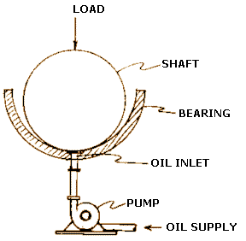
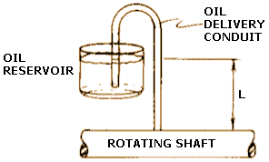

Antifriction Bearings (Rolling)
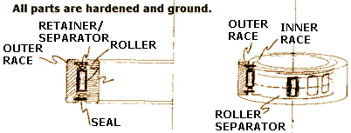

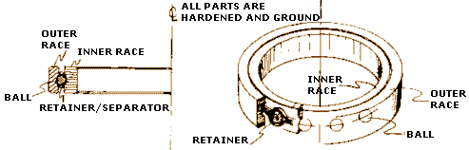

Types
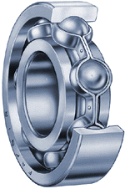  Photo courtesy The Timken Company  Cutaway view of a ball bearing |  | 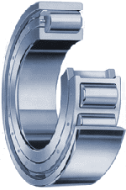  Photo courtesy The Timken Company  Cutaway view of a roller bearing
  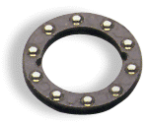
  Photo courtesy The Timken Company
  Ball thrust bearing
  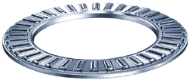
  Photo courtesy The Timken Company
  Roller thrust bearing
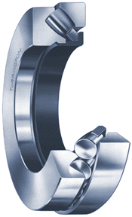  Roller Thrust Bearings | 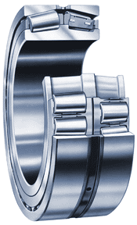  tapered Roller Bearings

Interesting Uses

Magnetic Bearings (High speed flywheels @90 000 RPM) high strain environments- heat, speed

Giant Roller Bearings- Used for moving great Objects ( ie Limestone rock for Pyramids)

Earthquake Proof Buildings- San Francisco International Airport – To withstand earthquakes, use a big bearing in each column.

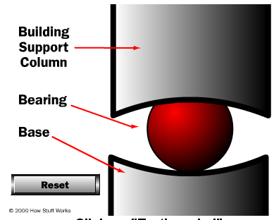

Questions?

Sources

http://www.efunda.com/DesignStandards/bearings/bearings_introduction.cfm

http://science.howstuffworks.com/bearing.htm

