
April 2, 2016
Project Title: Decoding human movement from surface Electromyogram (sEMG) for human machine interfaces (HMI)
Faculty: Dr. Ning Jiang
University of Waterloo, Department of Systems Design Engineering
519-888-4567 Ext. 33677 or by email at ning.jiang@uwaterloo.ca

Student Investigator: Bahareh Tolooshams
University of Waterloo, Department of Systems Design Engineering
email at btoloosh@uwaterloo.ca>
Dear [name of participant],
My name is Ning Jiang. I am a Professor at the Department of Systems Design Engineering, University of Waterloo. Together with my student Bahareh Tolooshams, we are developing new signal processing algorithms for surface Electromyogram (sEMG) to better extract neural control command that controls human voluntary movements. We are looking to recruit healthy and able-bodied participants and measure the electric signal generated by skeletal muscle (EMG) with non-invasive sensors.
What is the study about?
Human machine interface (HMI), technologies that facilitate interactions between human and machine (robots, computers etc.), will soon be embedded in every aspect of our society. Next generation HMIs need to sense human movement intentions faster and more reliably than ever before. To achieve this goal, however, alternative sensor modalities beyond mechanical sensors, which are exclusively used currently, must be incorporated. Recently, surface electromyogram (EMG) has been investigated for this purpose. sEMG is electric signals generated by muscles during contraction. This study seeks to significantly improve the way engineers and scientist extract information regarding human movement from sEMG, so that next generation HMIs can sense the movement of human, or even just the intentions to move, faster and more reliable than ever before.
How will I be involved in this study?
The study will take place at the University of Waterloo. The testing session will take about 2 to 3 hours. During the test, you will be asked to perform a series of wrist and hand contractions, such as wrist pronation and supination (rotating wrist), wrist flexion and extension etc. Instructions on what contraction to perform will be provide on the PC monitor. Surface EMG electrodes, as shown in the figure below, will be placed on the surface of your forearm to acquire the EMG signals. You can take break during the experiment session at any time you wish, and you can with draw from the experiment at any time you wish. All instrumentation used in the experiment will only measure signals generated by your body. They will not induce or emit energy into your body. It might be necessary to shave excessive body hair at the electrode sites. The shaving will be done with disposable shaver, which will only be used once.
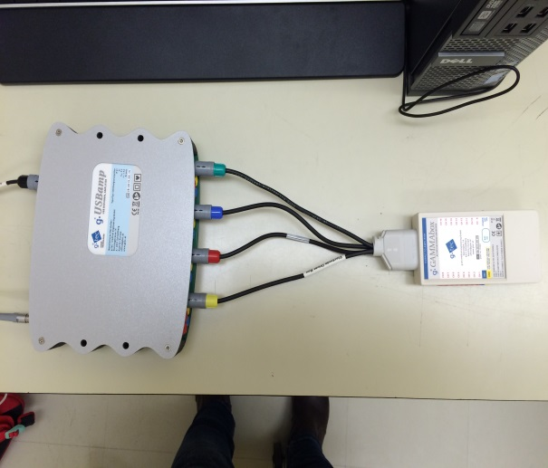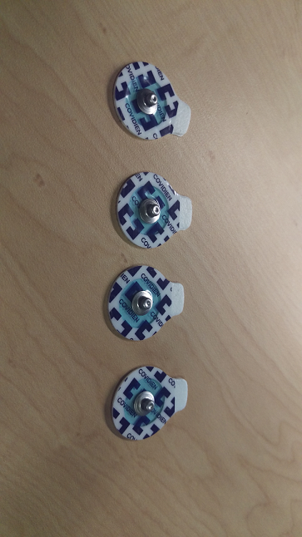
Instrumentation and materials for the experiment.
Left: the commercial bio-signal amplifier (gUSBamp, Guger Technologies, Austria) for acquiring surface EMG signals. The equipment is commercially manufactured and is CE certified and FDA approved for research.
Right: disposable surface EMG electrodes.

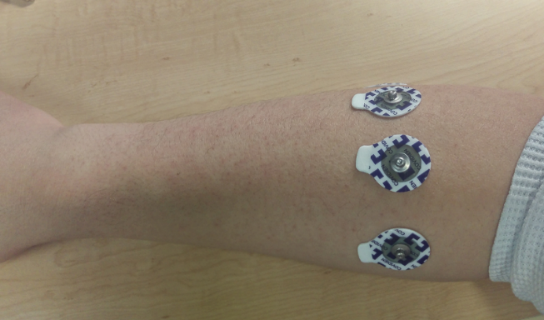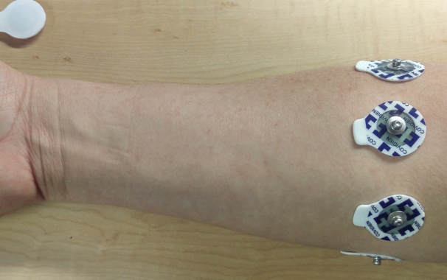
Electrode placements for the experiment.
Left: electrode placements on the lateral side of the forearm.
Right: electrode placements on the medial side of the forearm.
Note that the exact placement of the electrodes might different from participants to participants, since the size of the forearm different from participant to participant. The electrodes will be placed around the forearm, with equal distance. Normally, 7-8 electrodes will be used. All electrodes are disposable and will only be use once.

Will anyone know it was me?
All information we collect about you will be kept confidential and kept separate from your name or other identifying information, unless release is required by law.
You will not be identifiable in any publications or presentations resulting from this study. No identifying information will leave the University of Waterloo. All information that leaves the university will be identified using participant codes, not names.

The link between your name and the participant code will only be accessible by the research team. The link and study files will be stored separately and securely. Both files will be kept for a period of 5 years after the study has been completed. All paper records will be stored in a locked file cabinet in my UW office. All electronic records will be stored on password protected external hard drive, and secured in a locked drawer in my office. The data is only accessible by the researchers in my research group. At the end of the retention period, all paper records will be disposed of in confidential waste or shredded, and all electronic records will be deleted.
Do I have to do this?
Your participation in this study is voluntary. You have the right to not participate or withdraw from the study at any time without any impact to your current and future care or activities.
What are the risks and benefits?
During the preparation of the experiment, conductive gel and alcohol will be applied on the skin surface to facilitate data acquisition. In rarely cases, either the gel or alcohol may cause mild discomfort and irritation, which will dissipate quickly. If there are excessive hair around your forearm, shaving might be necessary to ensure the electrode will stay on the skin surface during the experiment. For this purpose, disposable one-time use shaver will be used. The risk associated with the experiment preparation procedure is minimal and will be no higher than in those during a routine physical checkup, such as the preparation of ECG measurement or an ultrasound exam. However, if you are allergic to latex or isopropyl alcohol, you should not participate this experiment.
If you have known prior neuromuscular disorders and/or motor sensory disorders, you should not participate in this experiment.
During the data acquisition of the experiment, muscular contraction of your forearm muscles at low to moderate level is required. And you can take breaks whenever you desire. The risk associated with these muscle contractions is no higher than a low intensity exercise targeted at upper limbs.
There is no direct benefit to you as a participant. The knowledge obtained through the study will be used to build next generation HMIs that provide faster and more accurate interaction between human, computers and robots.
Is there remuneration for my participation?
Your participation will be reimbursed at the rate of 15$ an hour, regardless if the entire experiment session is completed. It will be calculated based on the actual duration of your participation. Please note that the amount received is taxable. It is your responsibility to report this amount for income tax purposes. For non-UW participants, 5$ parking fee will also be reimbursed.
What if I have questions?
Please ask me to explain anything you do not understand before signing the consent form. If you have questions after today, you can contact me by telephone or email. My phone number is:
519-888-4567 ext. 33677 and my email address is ning.jiang@uwaterloo.ca. If you leave a message, I will get back to you as soon as possible.
This project has been reviewed and received ethics clearance through a University of Waterloo Research Ethics Committee. However, the final decision about participation is yours. Participants who have concerns or questions about their involvement in the project may contact:
Dr. Maureen Nummelin, the Chief Ethics Officer
Phone: 519-888-4567, Ext. 36005
Email: Maureen.nummelin@uwaterloo.ca.

