Department of Systems Design Engineering

University of Waterloo

PARTICIPANTS NEEDED FOR

RESEARCH IN

Estimating neural control information from surface Electromyogram (sEMG) for human machine interfaces (HMI)

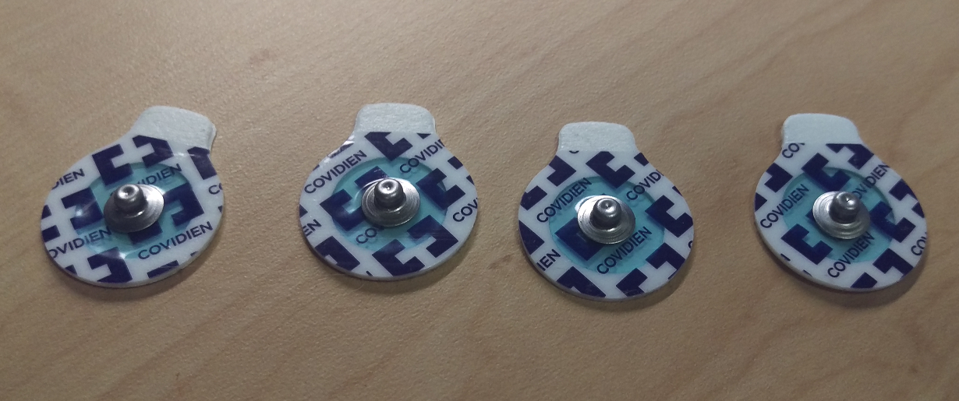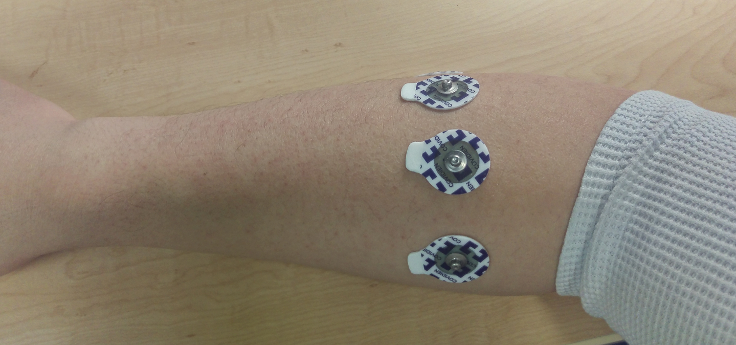 | 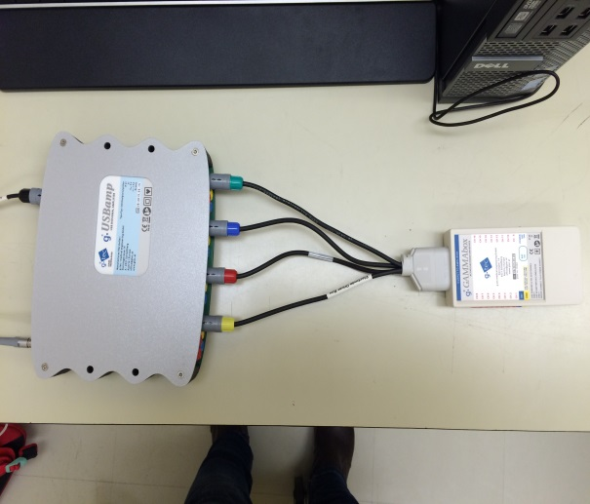
We are looking for volunteers to take part in a study on using sEMG to extract neural control information of voluntary human movements.

As a participant in this study, you would be asked to:
- Have EMG electrode placed on the forearm
- Perform a series of wrist and hand contractions;

Your participation would involve 1 session;
The session takes approximately 2 to 3 hours. A reimbursement of the participation is 15$ an hour, regardless if the entire experiment session is completed. For non-UW participants, 5$ parking fee will also be reimbursed.

The experiment will take place at the Myoelectric Control Lab (CPH-2385A).

For more information about this study, or to volunteer for this study,
please contact:
Prof. Ning Jiang
System Design Engineering Department at
519-888-4567 Ext. 33677
Email: ning.jiang@uwaterloo.ca
Or
Bahareh Tolooshams
Email: btoloosh@uwaterloo.ca
This project has been reviewed and received ethics clearance through a University of Waterloo Research Ethics Committee. However, the final decision about participation is yours. Participants who have concerns or questions about their involvement in the project may contact Dr. Maureen Nummelin, the Chief Ethics Officer at 519-888-4567, Ext. 36005 or Maureen.nummelin@uwaterloo.ca

